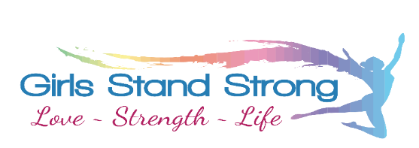

Tallangatta Retreat
27th – 29th March 2020
Agenda:
Day 1 - 27th March
5.00pm | Arrival
5.30pm | Welcome to retreat, icebreakers
6.30pm | Room Allocation
7.00pm | Dinner
8.00pm | GSS Session 1
9.00pm | Free Time, Games, Supper
10.30pm | Lights Out
Day 2 - 28th March
6.30am | Morning fitness (optional)
7.30-8.30am | Breakfast
9.00am | GSS Session 2 - Journaling
9.30am | Adventure session 1a: Flying Fox
10.30am | Morning Tea
11.00am | Adventure session 1b: Initiative Activities
12.00pm | GSS Session 3
12.30pm | Lunch
1.00pm | GSS Session 4
2.00pm | Adventure session 2: Canoeing/Paddleboarding/Cable bridge
4.00pm | Afternoon Tea (at lake)
4.30pm | GSS Session 5
5.30pm | Free time
6.30pm | Dinner
7.30pm | Free Time, Outdoor cinema, supper
10.00pm | Lights out
Day 3 - 29th March
6.30am | Morning fitness/walk (optional)
7.30-8.30am | Breakfast & pack up rooms
8.30am | GSS Session 6 - Journal
9.30am | Adventure session 3a: Climbing wall
10.30am | Morning Tea
11.00am | Adventure session 3b: Low ropes course
12.00pm | GSS Session 7
1.00pm | GSS Session 8 – wrap up
1.30pm | Lunch
2.00pm | Depart

What to bring:
Bedding – sheet & blanket or sleeping bag, pillow
Towels – 2- one bathroom, one workout/swimming
Toiletries – incl. soap, toothpaste, deodorant, sunscreen & insect repellent
Personal medication – clearly marked with your name
Sturdy walking shoes (runners ok)
Shoes (that will get wet)
Bathers
Waterproof jacket with hood
Warm jacket
Hat
Long shorts/pants & shirt/t-shirt – for adventure activities (no short-shorts or singlets)
Workout clothes
Casual clothes – t-shirts, shorts, pants, jumpers etc. (prepare for hot & cold days & nights)
Underwear and socks
Pyjamas & robe, slippers etc
Backpack
Torch
Plastic bag for dirty clothes

Personal devices – ipods, phones, jewellery etc. can be brought however no responsibility will be taken for lost/stolen/damaged items. Minimal use of phones will be encouraged to promote interaction throughout the retreat.
Girls are not to wear or take to adventure activities activities: Short shorts, singlets, thongs, slippers, open toe/unsturdy shoes, (crocs, slip on shoes etc), iPods, mobile phones, bracelets/necklaces, dangly earrings. Long hair must be tied up for activities and meal times.

No spending money is required.
Snacks may be brought but please limit number of snacks, and avoid nut-based products.

