GSS Retreat 2020 - Booking Conditions
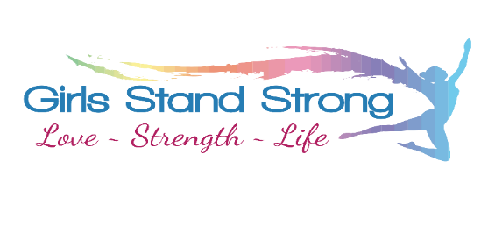
These Booking Conditions contain important information. It is essential that you carefully read and understand them.
The Booking Conditions constitute a contract between ‘Girls Stand Strong’ and ‘The Client’ for the services provided by Girls Stand Strong for the purpose of the Girls Stand Strong retreat.
The Client acknowledges that they have read, understood, and agree to be bound by these Booking Conditions by signing the Consent Form for participation of them/their child. Any queries regarding these Conditions should be raised with Girls Stand Strong.
PRICES AND PAYMENT
The price of the Girls Stand Strong retreat is $280 per participant. This price includes: all meals, accommodation, and participation in all sessions. This price does not include transport to and from the venue. No spending money is required at the retreat.
To reserve your place at The GSS Retreat, a non-refundable deposit of $50 is required by 2nd March, with full payment finalised by 16th March 2020. Payment plans can be negotiated if required.
No refunds will be paid if persons leave the Retreat for any reason after the event has begun. No refunds will be made for any accommodation, meals or services not utilised.
Bank Details:
Acct name: Girls Stand Strong
BSB: 640 000
Acct: 111 271 546
Please include your name as a reference.
CANCELLATIONS
Notification of cancellation must be made to Girls Stand Strong in writing. Cancellations may be refunded if written confirmation is received by the date specified in Table 1. Please note that Girls Stand Strong will only offer part refunds detailed in Table 1 in order to cover pre-paid expenses for the Retreat such as accommodation and booked activities.

Table 1: Cancellation Dates and Refunds
Cancellation Date | Refund
By 9th March 2020 | 50% of monies paid (excl. deposit)
By 16th March 2020 | 25% of monies paid (excl. deposit)
After 16th March 2020 | No refund

TRANSFER OF BOOKING
Bookings may be transferred to a third party – this is to be negotiated between the Client and the third party. Girls Stand Strong does not assume any role or responsibility for this process, including any agreements between the client and the third party for reimbursement of costs. The booking will remain the responsibility of the Client until Girls Stand Strong is advised of the third party details.
PUBLICITY
You agree that Girls Stand Strong may use images/video of you/your child taken during the event without recourse to you and without compensation to you, for publicity and promotion purposes only through whatever medium it chooses.
TRANSPORT
You give permission for your child to travel in private vehicle to and from activities as required throughout the Retreat. All drivers are fully licenced and experienced.
HEALTH & FITNESS
It is your responsibility to advise Girls Stand Strong of any pre-existing medical condition and/or disability that might reasonably be expected to increase the risk of you/your child requiring medical attention, or that might affect the normal conduct of activities. If requested by Girls Stand Strong you/your child may be required to provide an assessment of your medical condition by completing an additional Health & Fitness Questionnaire and/or a Medical Clearance Form, the latter which requires certification by a medical practitioner. Should, at any time during the Retreat, you/your child experience pain or a medical condition, Girls Stand Strong advises that you/your child cease the exercise immediately, and seek assistance.
Girls Stand Strong suggests that you/your child is insured with the appropriate ambulance cover. We will not hesitate to call an ambulance if required, and any costs associated with the service will be at the expense of the child’s family.
ASSUMPTION OF RISK
Participation of some activities in the retreat involves inherent risks that may include the possibility of injury or death. The possibility of experiencing all or some of these risks is likely to be higher if participation involves undertaking adventure-based activities, or entering environments where there is dangerous wildlife. It is the Client’s responsibility to accustom themselves with the risks and ensure that appropriate gear and precautions are exercised when undertaking these activities.
EXPECTATION OF INDIVIDUALS
There is an expectation that participants are responsible for their welfare and safety at all times.
The actions and behaviour/s of individuals should be respectful of other participants, and should not inhibit the enjoyment of others during the retreat.
Any unacceptable behaviour will not be tolerated and, in extreme cases, may result in parents being requested to collect their child.
DAMAGE, LOSS & THEFT
Individuals are responsible for storing and securing items of value. Girls Stand Strong will not be held responsible for any costs arising from damaged, lost or stolen items.
CONSENT
By signing the Consent Form (available on website), you withdraw the right to make any claim of any kind against Girls Stand Strong for any injury, illness, or financial loss occurring at, or arising from, the Retreat.

